Network Architecture-1

Assignment-3

Name: Vineela Chowdary

Student ID:16208640

1) Go Back N:

It is an example of ARQ Automatic Repeat Request protocol. Here the sending process sends the frames specified by the window size without receiving the acknowledgement from the receiver. The sequence of the next frame to be received is kept in track by the receiver.

Here 5 consecutive data segments are transmitted between Host A and Host B and the second segment is lost . Because of losing segment the retransmission of data segments occurs.

As 5 segments are transmitted and one segment is lost finally 9 segments are transmitted and 8 acknowledgements are received.

The number of data segments send by Host A = 9

The order of sequence numbers transmitted is Seq-1, Seq-2, Seq-3, Seq-4, Seq-5, Seq-2, Seq-3, Seq-4, Seq-5

The number of Acknowledgements received = 8

The order of the Acknowledgements received are Ack-1, Ack-1, Ack-1, Ack-1, Ack-2, Ack-3, Ack-4, Ack-5.

2) Selective Repeat:

Here the sender sends the frames without waiting for the individual acknowledgements

Here as the second segment is lost the host A retransmits segment 2 and host B send back the acknowledgment to host A

The number of data segments send by Host A = 6

The order of sequence numbers transmitted is Seq-1, Seq-2, Seq-3, Seq-4, Seq-5, Seq-2.

The number of Acknowledgements received = 5

The order of the Acknowledgements received are Ack-1, Ack-3, Ack-4, Ack-5, Ack-2.

3) TCP:

It is the main protocol of IP protocol suite. It provides reliable, ordered and error checked delivery of stream of octets.

Here the buffer will store the segments even though the second segment is lost.

The number of data segments send by Host A = 6

The order of sequence numbers transmitted is Seq-1, Seq-5, Seq-13, Seq-15, Seq-19, Seq-5

The number of Acknowledgements received = 5

The order of the Acknowledgements received are Ack-5, Ack-5, Ack-5, Ack-, Ack-21.

(b) The protocol that successfully delivers all five data segments in shortest time interval if the timeout values for all the three protocols are much longer than 5 RTT is **TCP.**

(2)

(a) Given in the problem α= 0.1

Four acknowledgements have been returned with corresponding sample RTT. Those RTT's are sample RTT4, sample RTT3, sample RTT2, sample RTT1

We know that the formula for

Estimated RTT = (1- α)*Estimated RTT + α*Sample RTT

Here we have to calculate for four estimated RTTs

For first sample RTT, Estimated RTT1 = Sample RTT1

For second sample RTT, Estimated RTT1 = (1- α) Estimated RTT1 + α*Sample RTT2

= (1-0.1)Estimated RTT1 + 0.1Sample RTT2

= 0.9Sample RTT1 + 0.1Sample RTT2

For third sample RTT, Estimated RTT3 = (1- α) Estimated RTT2+ α*SampleRTT3

= (1-0.1)[0.9Sample RTT1 + 0.1Sample RTT2] + 0.1sample RTT3

= 0.1SampleRTT3+ 0.09SampleRTT2 + (0.9)2SampleRTT1

For fourth sample RTT, Estimated RTT4 = (1-α)Estimated RTT3 +α*Sample RTT4.

=0.9(0.1SampleRTT3+ 0.09SampleRTT2 + (0.9)2SampleRTT1) +0.1sample RTT4

=0.09sample RTT3+0.081sample RTT2+0.729sample RTT1+0.1sample RTT4

(b)

The generalized formula for n Sample RTTs is

For n Sample RTT, Estimated RTTn = (1-α)n-1sampleRTT1+α(1-α)n-2sample RTT2+…+α(1- α)1sampleRTTn-1+αsampleRTTn.

Generalised Estimated RTTn =  j +(1-α)n-1sampleRTTn.

= j+(0.9)n-1sampleRTTn.

(c) The formula for Estimated RTT when n approach infinity

The second term (1-α)n-1sampleRTTn approaches zero when n approaches infinity

Estimated RTT α =  j

=  j

When n approaches infinity the Estimated RTT decrease exponentially. So this procedure is called Exponential moving average.

(3)

(a) According to the problem given that

The TCP uses AIMD for its congestion control without slow start.

The Congestion window increases by 1 MSS every time and RTT remains constant.

The time taken for cwnd to increase from 5 MSS to 6 MSS is 1 RTT

The time taken for cwnd to increase from 6 MSS to 7 MSS is 2 RTTs

The time taken for cwnd to increase from 7 MSS to 8 MSS is 3 RTTs

The time taken for cwnd to increase from 8MSS to 9 MSS is 4RTTs

The time taken for cwnd to increase from 9 MSS to 10 MSS is 5 RTTs

Therefore the time taken for cwnd to increase from 10 MSS to 11 MSS is 6 RTTs

(b) Average throughput = (Total message segments sent)/(Total time)

Total message segments sent = (5+6+7+8+9+10)MSS

= 45 MSS

Total time = 6 RTT

Therefore average throughput = 45 MSS/6 RTT

= 7.5 MSS/RTT

Laboratory Homework:

1) The IP address of source is 192.168.1.102

The TCP port number of source is 1161

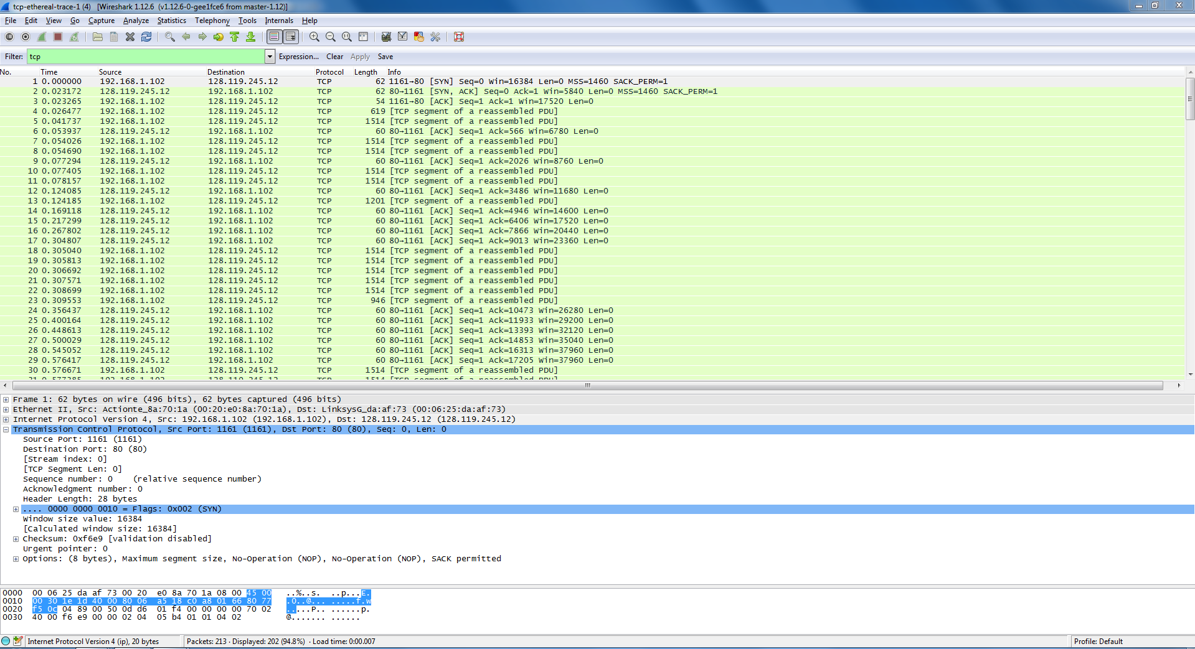

2) The IP address of gaia.cs.umass.edu is 128.119.245.12

The port number used for sending and receiving the TCP segments is 80

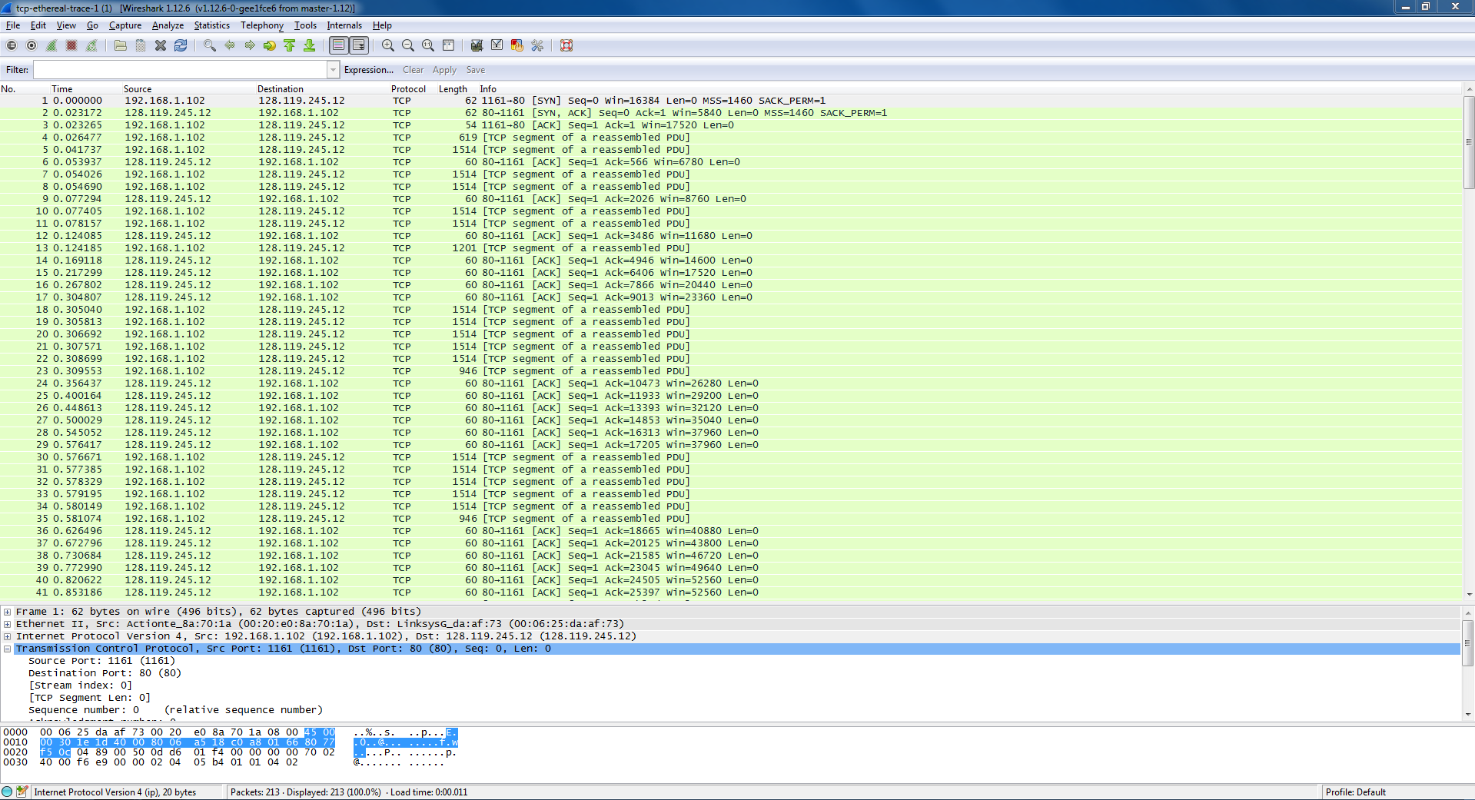

3) The sequence number of the TCP SYN segment is 0

The flag identifies the SYN segment as SYN :Set in Flags : 0*02 is set as 1

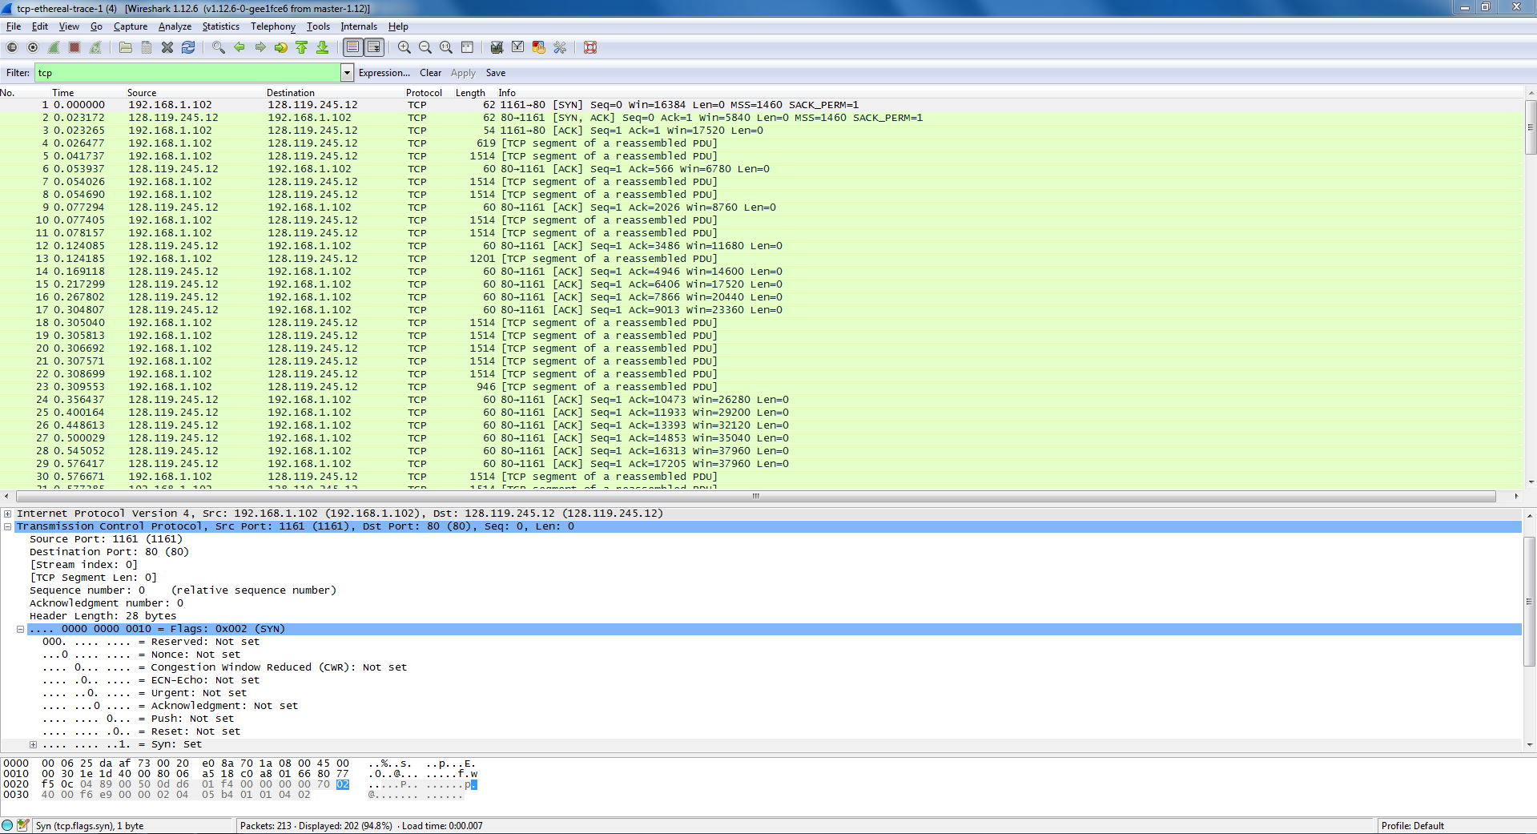

4) The sequence number of the SYNACK segment is 0

Acknowledgement field in the SYNACK segment is 1

gaia.cs.umass.edu determines the value of the acknowledgement field in the SYNACK segment. The segment that identifies the segment as a SYNACK segment is Flags: 0*12(SYN, ACK) where SYN is set to 1. ACK is set to 1.

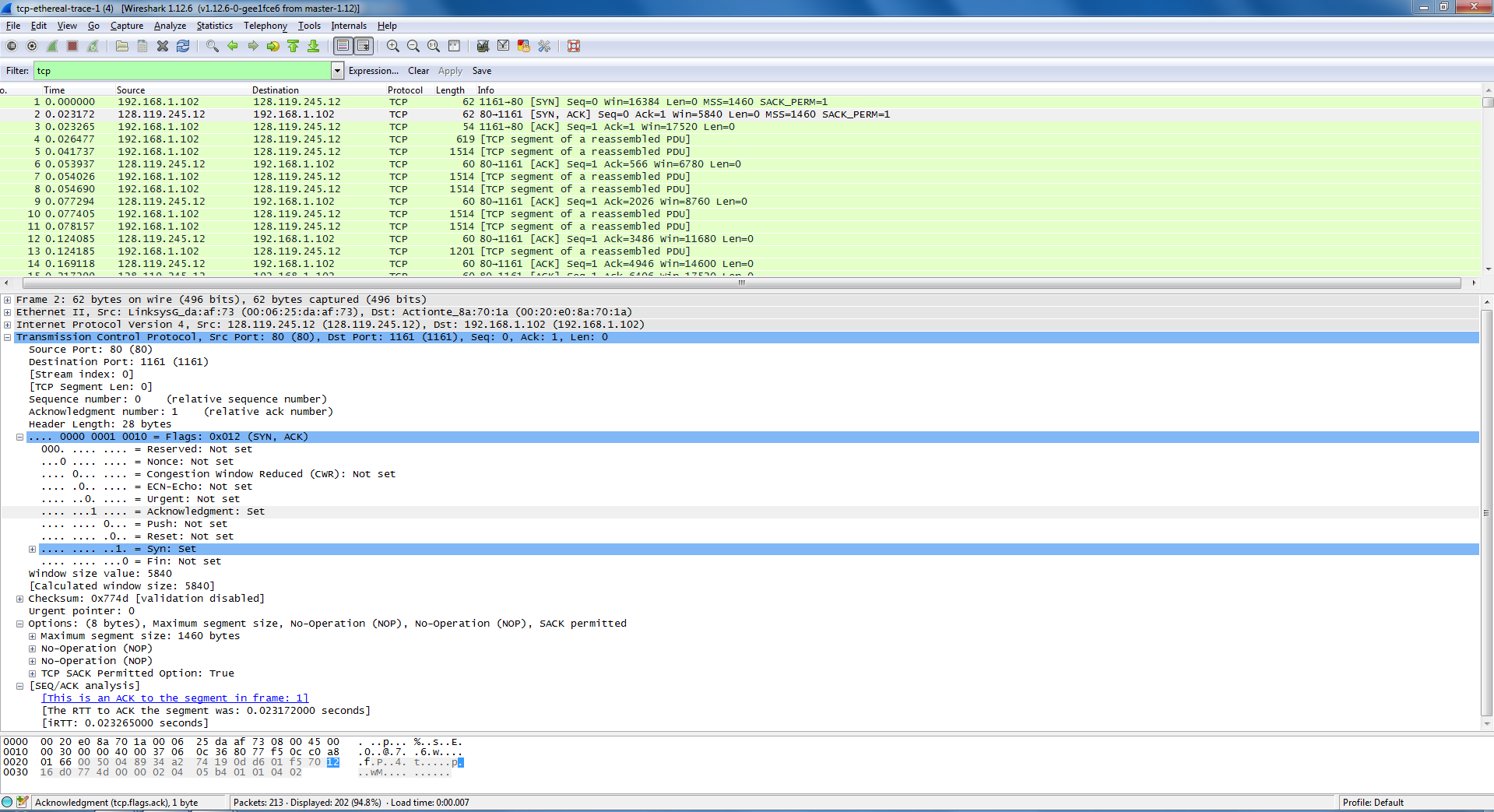

5) Sequence number of the TCP segment containing the HTTP POST command is 1. It is found as 4.

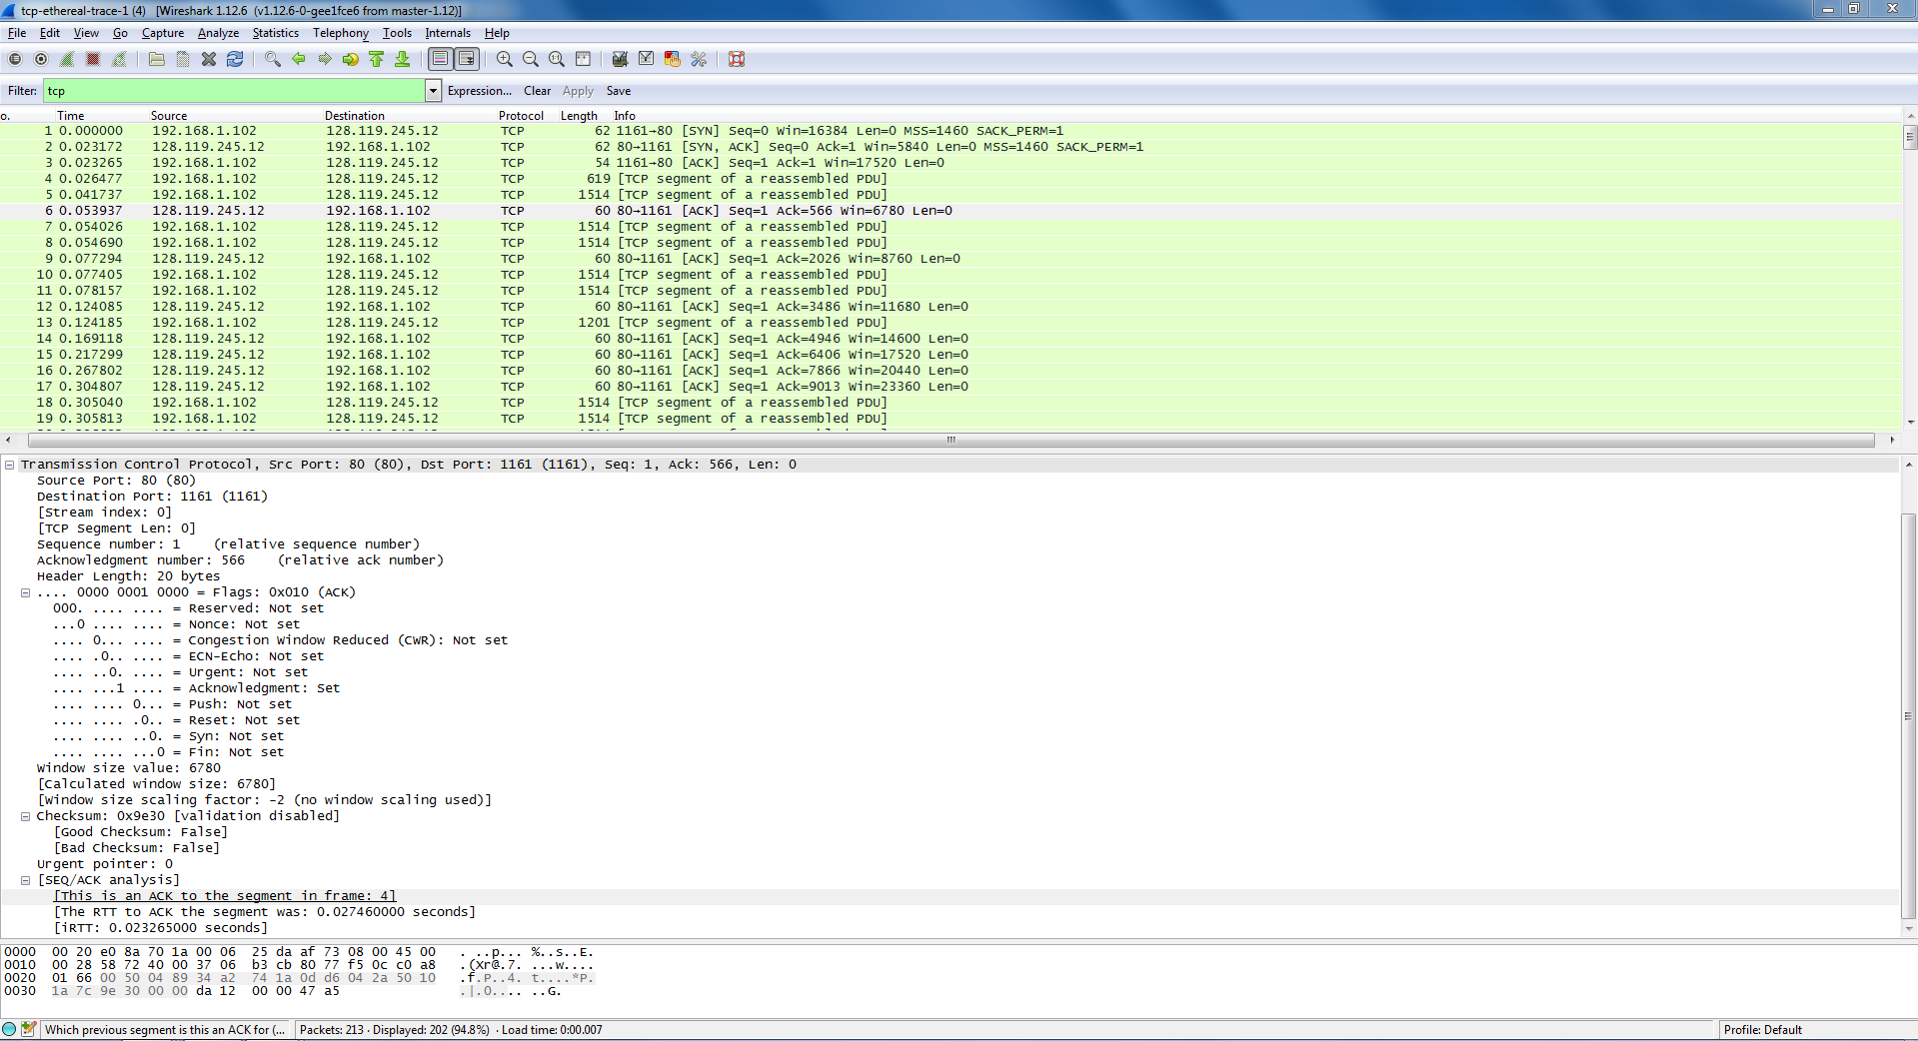

6) Considering Frame 4 as the first segment. The sequence numbers of first six segments for frames 4,5,7,8,10,11 are

Frame No Sequence Number Time when the segment was sent

4 1 0.026477

5 566 0.041737

7 2026 0.054026

8 3486 0.054690

10 4946 0.077405

11 6406 0.078157

The acknowledgement time for the segments 6,9,12,14,15,16 are

Frame No Time when the acknowledgement was received

6 0.053937

9 0.077294

12 0.124085

14 0.169118

15 0.217299

16 0.267802

The difference between TCP segment sent and its ACK received are as follows:

0.053937-0.026477 =0.02746

0.077294-0.041737 =0.035557

0.124085-0.054026 =0.070059

0.169118-0.054690 =0.114428

0.217299-0.077405 =0.139894

0.267802-0.078157 =0.189645

The Estimated RTT is given by the formula

Estimated RTT = α*Sample RTT + (1-α)*Estimated RTT

For α = 0.125, then Estimated RTT = 0.125*Sample RTT + 0.875*Estimated RTT

Estimated RTT’s are calculated as follows:

Estimated RTT1= sample RTT =0.02746

Estimated RTT2= 0.125*0.03557 + 0.875*0.02746 =0.0285

Estimated RTT3=0.125*0.070059 + 0.875*0.0285=0.0337

Estimated RTT4= 0.125*0.11443 + 0.875*0.0337=0.0438

Estimated RTT5= 0.125*0.13989+ 0.875*0.0438=0.0558

Estimated RTT6= 0.125*0.18964+ 0.875*0.0558=0.0725

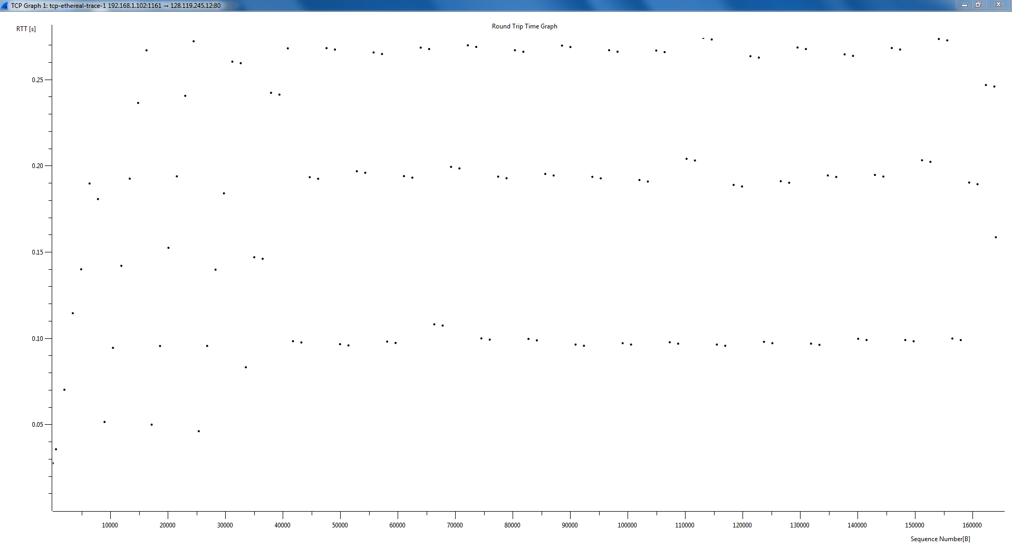

7) Length of the first TCP segments is 565

Length of the remaining TCP segments is 1460

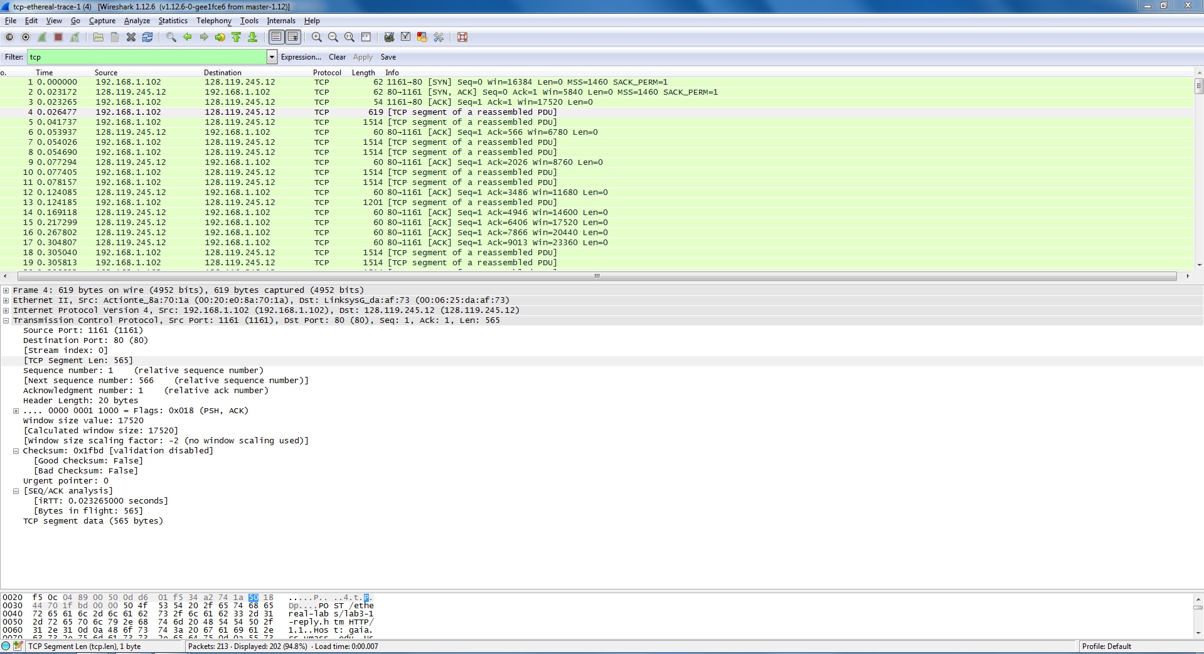

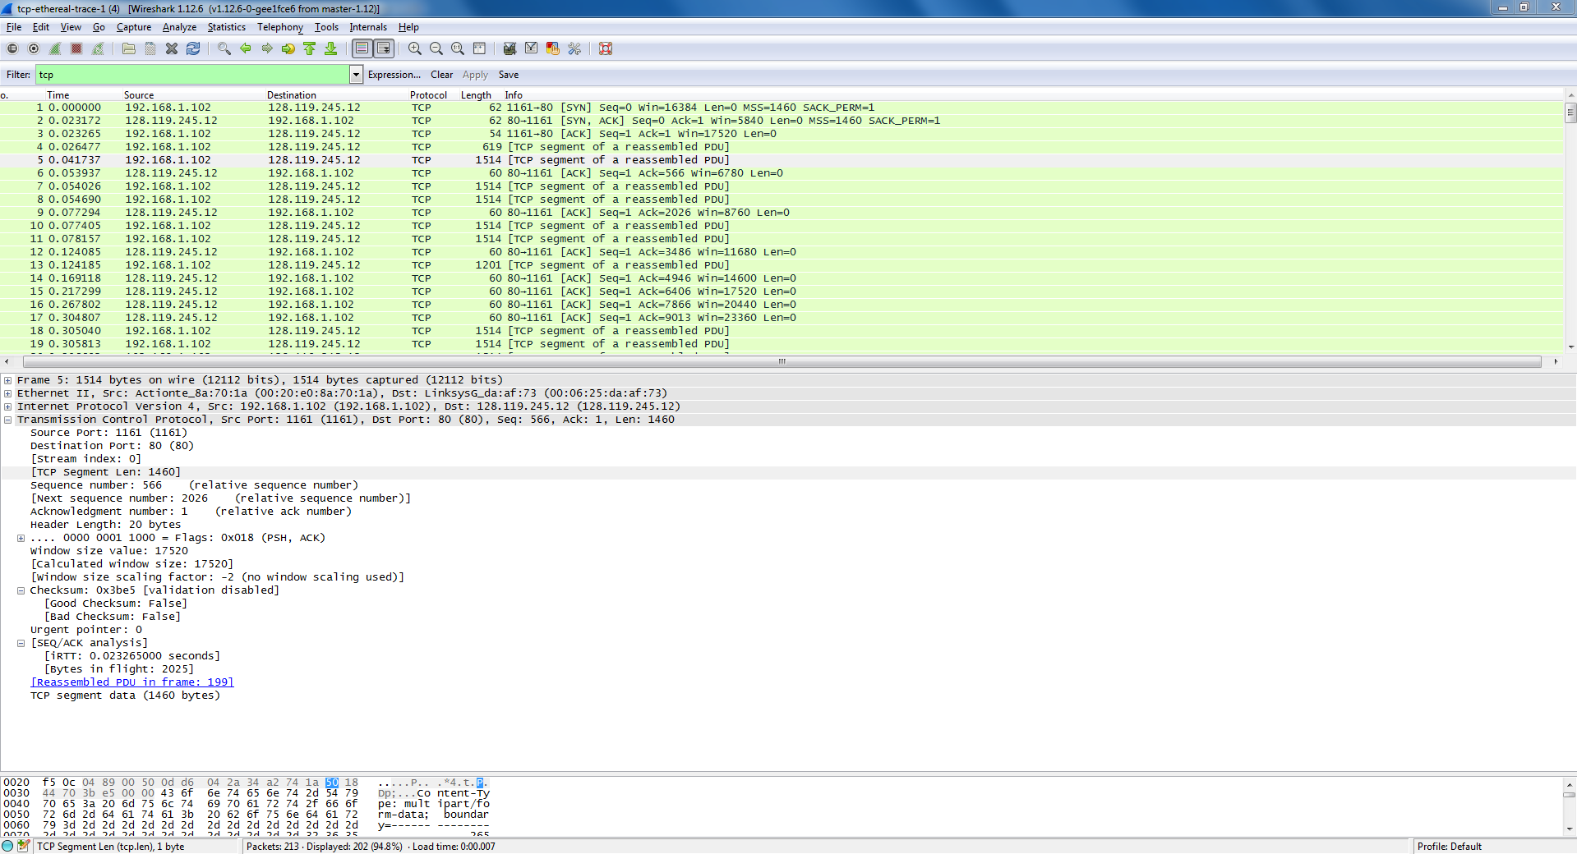

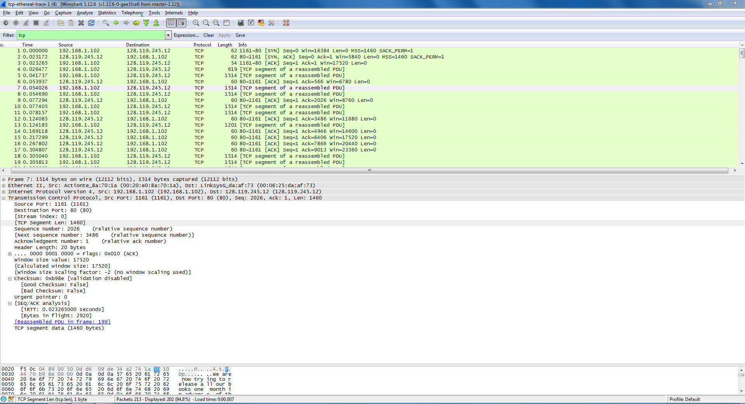

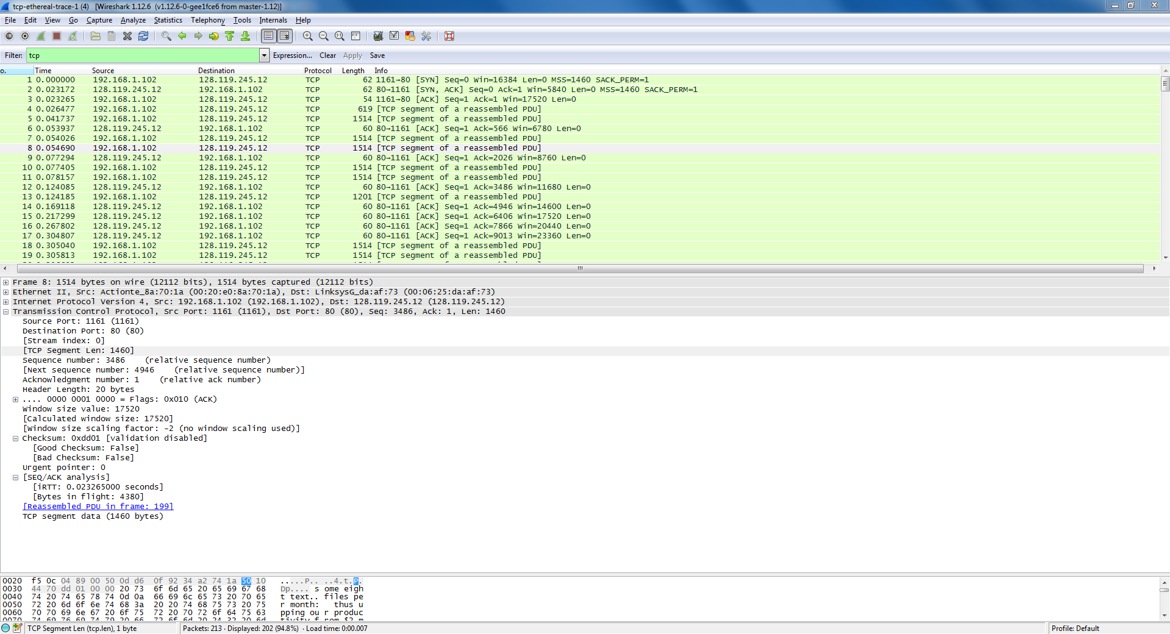

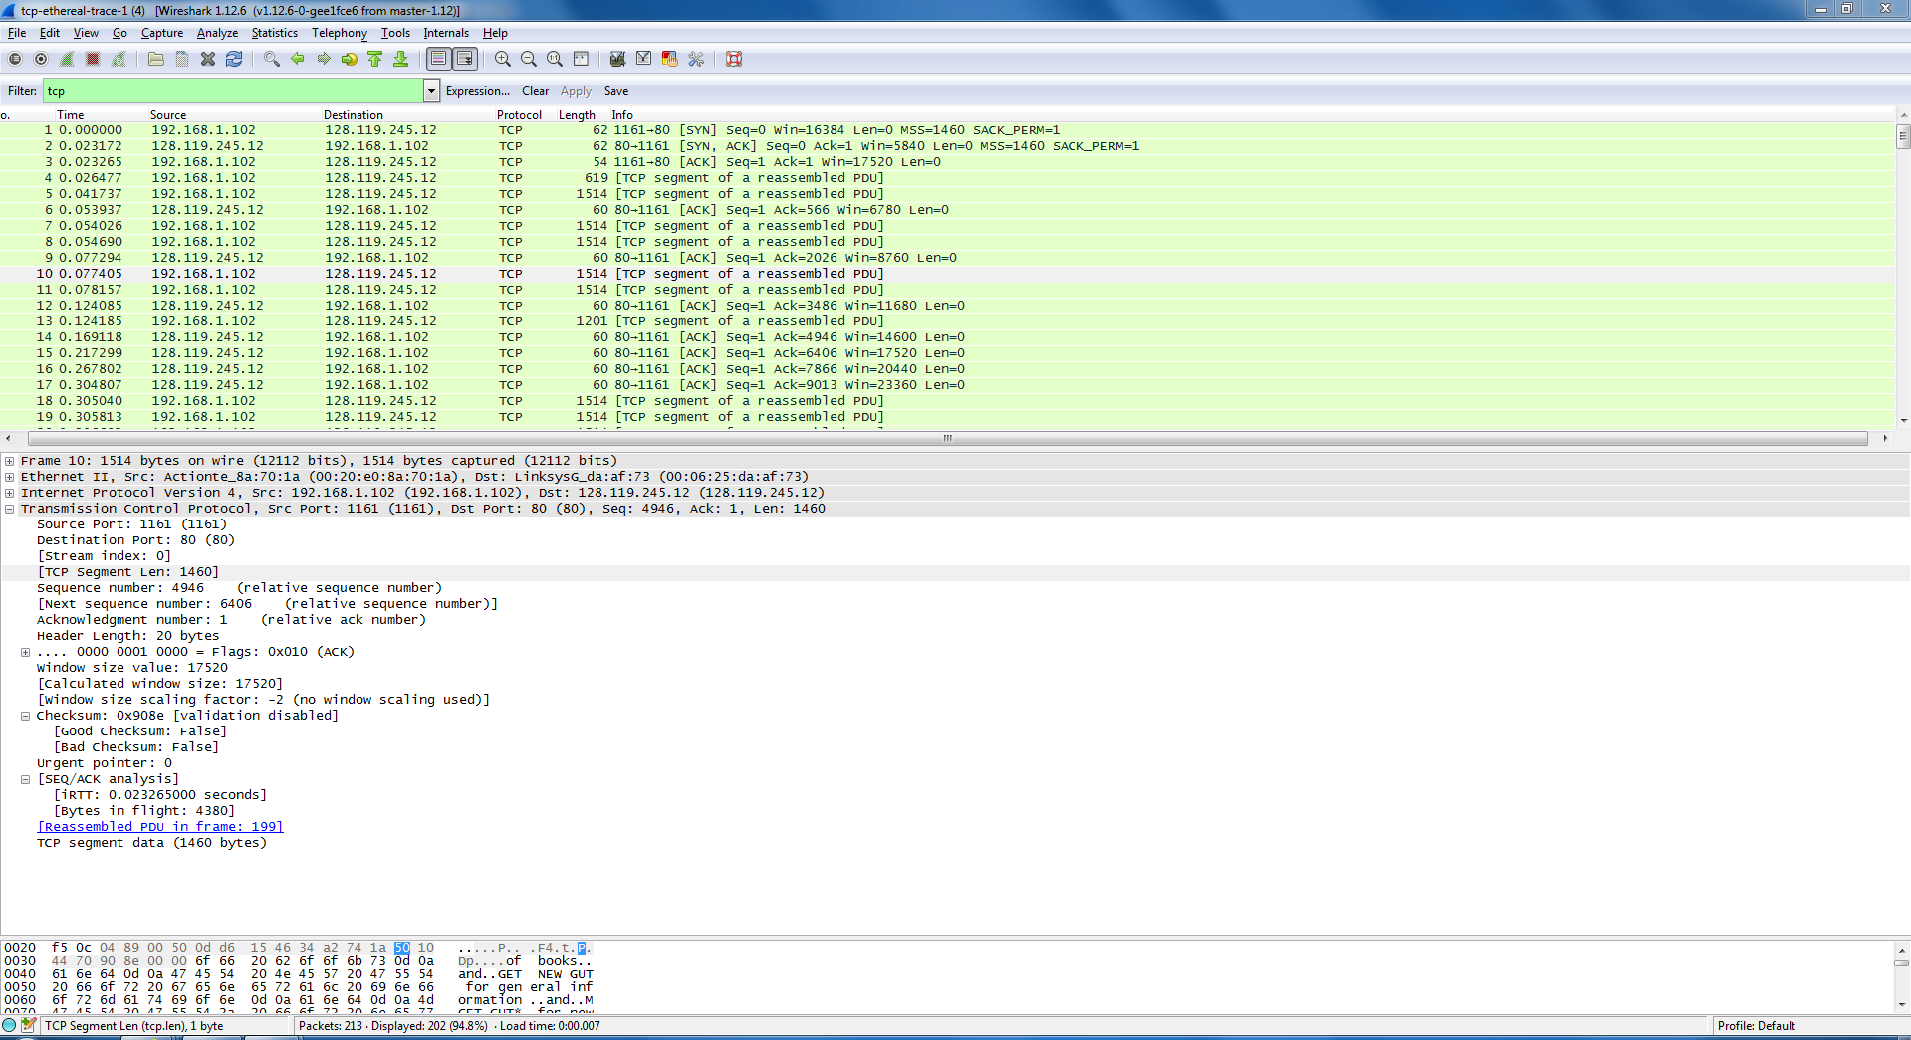

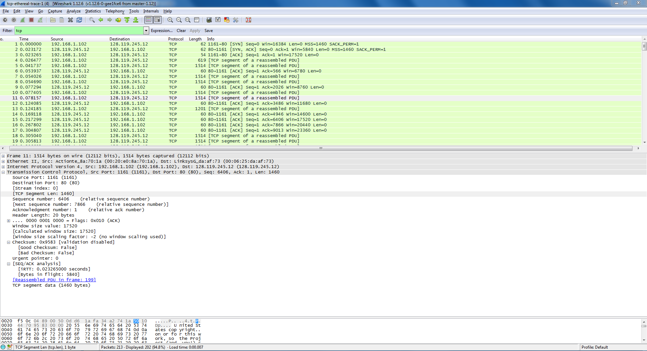

8) The minimum amount of available buffer space advertised at the receiver for the entire trace is 5840

No the lack of receiver buffer space never throttle the sender

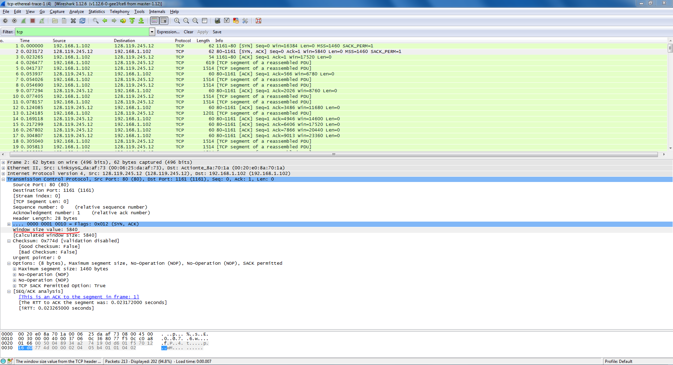

9

9) No there are no retransmitted segments in the trace file. By seeing the stevens graph we can say that there are no retransmissions as the sequence number is not repeated.

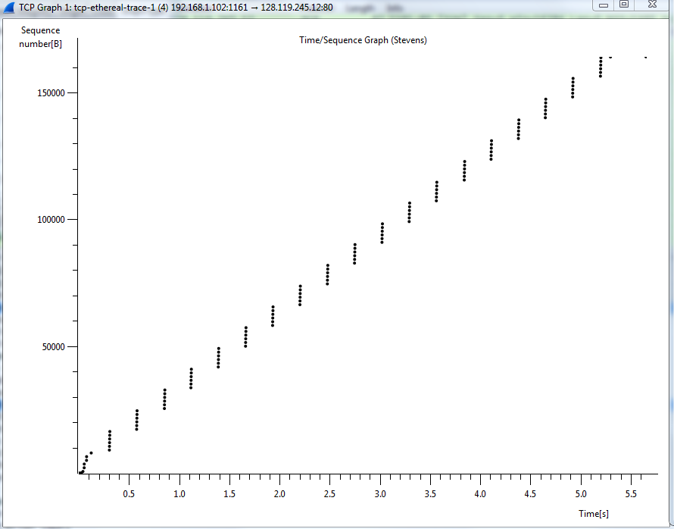

1

10)

The receiver acknowledges the data in an ACK which is equal to difference between the two consecutively acknowledged sequence numbers

Following are the cases in which receiver has acknowledged every other received segment

For the first ACK segment receiver acknowledges 565 bytes

From 2nd to 6th segment it acknowledges 1460 bytes.

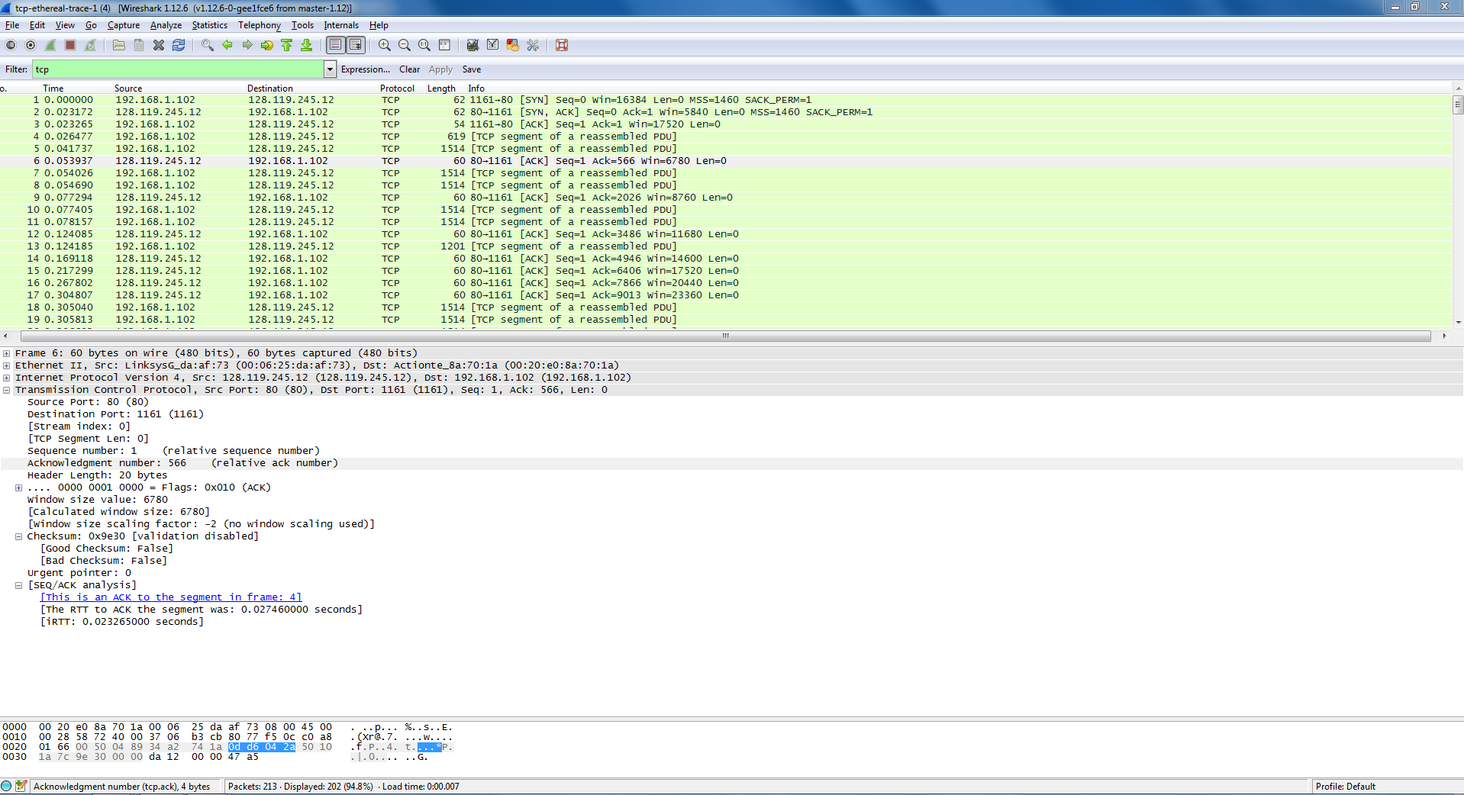

11) Throughput = (data transmitted) / (time taken for transmission)

Data transmitted = (164091 – 1) =164090 Bytes

Time taken for transmission= (5.455830 – 0.023265) = 5.432565Sec

Therefore Throughput = 164090 /5.432565

= 30.20kbps



